**SCOIL NÁISIÚNTA NA CATHRACH**

**Information Booklet**

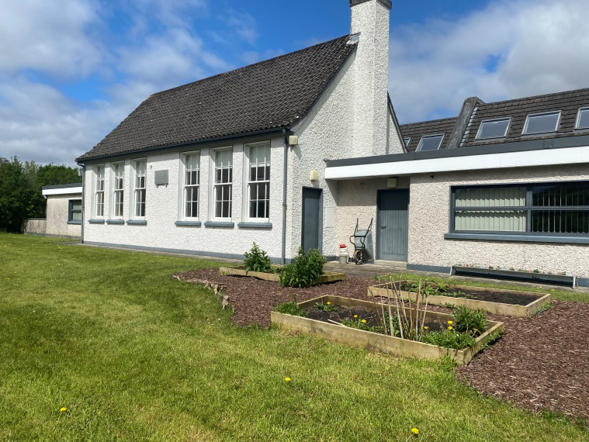

Contents

School Crest

Principal’s Welcome

Chairperson’s Address

Board of Management

Administrative/Circular Policies

New Entrants/New Parents

Brief History of Cahir School

PE / School Lunches

School Outings

Sacraments

Parent/Teacher Meetings

Green Schools Project

Points to Note

Class Rules

Staff

**Tús Maith**

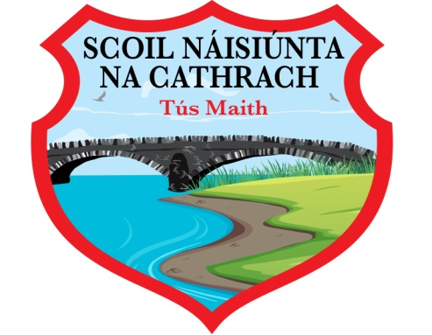

***Tús Maith***

The expresssion “Tús Maith” means “a good start”. Our logo incorporates the Roughty Bridge and the Roughty River which are in close proximity to the school.

**Principal’s Welcome**

A warm welcome to you all, and many thanks for choosing Cahir National School for your child. We hope that in the coming years, the experience of Cahir National School for you and for your child will be a good one.

Our aim, as outlines in our mission statement, “…is to provide for the academic, physical, emotional, social and spiritual education of our pupils. The varying needs of all the children, the talents, personalities and learning styles of both pupils and teachers will determine our delivery and approach.

We endeavour to build on the children’s strengths and support them when they encounter difficulties. We recognise that the parents are the primary educators of their children and we depend on their support and co-operation, together with that of the Board of Management, the Department of Education and Skills, and the wider community.

It is our hope that Cahir National School, along with all the partners in Education can achieve these goals for your child. ***Marian Hanley, Principal***

**Chairperson’s Address**

The Bishop, as Trustee of the school on behalf of the local Catholic Community, is recognised as the Patron of the school. In that capacity, the Bishop has certain rights and responsibilities, particularly in relation to the appointment of the Board of Management, the appointment of staff, and school finances.

Cahir National School aims to provide a happy, positive and secure learning environment where each child can grow and develop socially, physically, academically, spirtually and emotionally.

Our ethos reflects and respects the values and traditions of the community in which it is situated. It depends on the co-operation of pupils, parents, teachers, Board of Management, Parents’ Association, the parish and the community.

***Fr George Hayes PP***

***Chairperson Board of Management***

**Board of Management - 2024 – 2027**

**Members of B.O.M**

Chairperson Fr George Hayes

Secretary/Principal Marian Hanley

Patron’s Nominee Jean McGearailt

Parent Nominees Aoife Sheehan

Brian Young

Teacher Nominees Celine Lynch

Community Nominees Penny Crowley

Colm Horgan

The Board of Management is a representative body of parents, teaching staff, patron and community coming together, working on a voluntary basis, to manage the school that educates the children in the locality.

**Administrative Policies in Cahir National School**

1. Discipline Policy
2. Enrolment Policy
3. Special Needs Policy
4. Anti-Bullying Policy
5. Relationshop & Sexuality Education Policy
6. Critical Incident Policy
7. Data Protection Policy
8. Attendance Strategy
9. Health & Safety Policy
10. Child Protection Policy
11. School Outings Policy
12. Internet Acceptable Use Policy
13. Information & Communication Technology Policy
14. Work Experience Policy
15. Mobile Phone & Electronic Device Policy
16. External Coaches Policy
17. Administration of Medication Policy
18. Primary School Acceptable Use Policy
19. Swimming Policy

Curricular Policies

1. Maths
2. English
3. Irish
4. Science
5. History
6. Geography
7. Visual Arts
8. Physical Education
9. Music
10. Drama
11. Social Personal Health Education

**All policies are available at the school office.**

**New Entrants/New Parents & Guardians**

* Enrolment forms are available at the school office
* Forms to be returned to the school office before January 31st of the year the child is starting school
* Information day of parents/guardians
* Induction day for pupils/parets/guardians in June

General information about the school is available on our school website <https://www.cahirschool.ie>

**Brief History of Cahir National School**

The history of Cahir National School reaches back to 1826 when the Second Report of Commissioners of Irish Education Enquiry details the existence of a hedge school with a master, Daniel Sullivan, and 59 pupils in attendance.

This school is recalled as having been situated in nearby Shanagarry. A new school was built in 1834 at Cahir by local labour with funding from the Catholic Parish of Kenmare. It did not come under the National Board of Education until 16th December 1847 (during the Great Famine).

By 1859 there were 80 pupils enrolled at Cahir National School, its building remaining in use until replacement in the 1960s. The school was extensively extended in the years 2004 and 2014 and today, the school boasts three big classrooms, a resource/SET room, a halla for performances and an office. The school also contains ample storage areas.

**P.E. and Tracksuits:**

The children have one hour of P.E. each week on a Thursday. Your child should wear comfortable clothes, i.e. track pants and suitable top and trainers to school on this day, to be able to partake in PE in comfort.

**School Lunches:**

Cahir National School has adopted a “HEALTHY LUNCHES” policy. This policy was developed to assist parents in providing healthy lunches for their children in school and your co-operation is required to make it work.

***YES*** - sandwich, cheese, cheese strings, yoghurt, yops, fruit juice, fresh fruit, dried fruit, water, popcorn

***NO*** - fizzy drinks, glass bottles, cans, chewing gum, crisps and sweets. A little treat – biscuit, mini bar etc – is allowed on **Friday** only ***Morning break 11.00am –11.10am Lunch break 12.40pm – 1.10pm***

Students have only 15 mins to each their main lunch. Please remember smaller children don’t need large amounts of food. Make sure snacks/drinks/lunchboxes are easy to open … yoghurts are best avoided in infant classes.

**School Outings:**

Educational tours/school trips usually take place in the month of June. The class teacher will decide the date and destination of the school trip. All school trips musy be approved and sanctioned by the Board of Management. The class teacher may, for a variety of reasons, decide that a school trip/outing is not appropriate. The School’s Outing Policy will inform the decisions.

**Sacraments:**

Cahir & St John’s National Schools join together every year for First Holy Communion and Confirmation.

**Holy Communion** is usually held in May for the children in second class. The students of Sixth Class prepare for **Confirmation** each year. The date is decided in conjunction with the Bishop.

**Parent/Teacher Meetings:**

Annual Parent/Teacher meetings take place in November each year. These meeting occur out of school hours and appointment times will be arranged with you in advance. Parents wishing to meet with a teacher at any other time of the year to discuss issues arising with their child, should telephone the school secretary to arrange an appointment. A teacher wishing to meet with the parents of a student in their class will ask the school secretary to telephone or write to the parents to arrange an appointment.

**Green Schools Project:**

Cahir National School participates in the Green School’s programme and are currently applying for its flag.

A committee of pupils with representatives from 2nd to 6th class meet regularly to plan activities and initiatives to keep our school “Green”. The programme is co-ordinated with Deputy Principal, Ms Clara Brosnan

**BE GREEN BE CLEAN BE A TEAM**

**Points to Note:**

**Starting time & Break times**

* Starting Time 9.20am
* Finish Time 3.00pm
  + - * 2pm for J.I/S.I
* Roll Call 10.00am
* Break Times 11.00am – 11.10am
  + - * 12.40pm – 1.10am (lunch break)

**Absences** – written notes or emails please

* Children with absences of 20 days – Welfare Board must be informed by the School.
* Children withdrawn early for appointments etc or brought to school late must have written notes or an email sent outlining the explanation
* Birthday cards/invitation cards etc – not to be distrubuted in school
* Mobile phones/soccer cards, tippex etc – not permitted in school

**Field Trips:**

Cumman na mBunscoil – The Children of 5th and 6th classes of Cahir National School has been involved in boys and girls football (September – November) every year. The children compete against other County Kerry schools. These events depend upon the goodwill of our teachers who coach, and prepare the children for these games.

The school strip consists of a red/black jersey and black shorts.

At all times during football/soccer training, and while playing matches, pupils ***must*** wear a gumshield.

The school also holds an annual, non-competitive sports day with participation and enjoyment for ALL. The school may call upon parents to support and assist the smooth running of this annual event.

**Swimming Lessons:**

During the year students from Cahir National School avail of swimming lessons at the Kenmare Bay Leisure Centre. Children travel to and from school/pool by bus.

**Parking at the School:**

The front yard has a designated staff carpark. The playground area to the side of the school is the designated area for drop off in morning and pick up in the evening time.

**Local Churches:**

Holy Cross Church, Kenmare

Contact details and principal service times are set out below:

**ROMAN CATHOLIC CHURCH**

Fr George Hayes PP

The Presbetry, Kenmare

Tel: 064-6641352

Service Times:

Monday – Friday at 10am

Saturday 7.30pm

Sunday 9am and 12 noon

**Cahir National School**

***Official School Rules***

There are six official school rules that are in display in each classroom. These are

1. Respect your teacher and listen to others in the class.
2. No running, jumping or horseplay in the classroom or corridor.
3. Use your indoor voice.
4. Put up your hand and wait your turn.
5. Stop and Think
6. Treat others as you would like to be treated yourself.

**Staff in Cahir School**

|  |  |
| --- | --- |
| Ms Marian Hanley | Principal/Class Teacher |
| Ms Clara Brosnan | Deputy Principal/SET Teacher |
| Ms Celine Lynch | Class Teacher |
| Ms Sandra Mahony | SNA |
| Ms Theresa O’Shea | SNA |
| Mrs Susan Hennessy | SNA /Secretary |

Postal address: Cahir National School

Cahir, Kenmare, Co. Kerry, V93 TD4V

Telephone: 064-6642244

Email: cahirschool@gmail.com

Website address: <https://www.cahirschool.ie>